


COLLEGE FEEDBACK LOGGER

A PROJECT REPORT

Submitted by

AAKASH S (310624243001)
DEEPAKRAM V (310624243036)

in partial fulfilment for the award of the degree
of
BACHELOR OF TECHNOLOGY
IN
ARTIFICIAL INTELLIGENCE AND DATA SCIENCE

EASWARI ENGINEERING COLLEGE, RAMAPURAM
(AUTONOMOUS)

ANNA UNIVERSITY: CHENNAI 600 025
NOV-DEC 2025

BONAFIDE CERTIFICATE

Certified that this project report titled “COLLEGE FEEDBACK LOGGER” is the Bonafide work of “AAKASH S (310624243001)
DEEPAKRAM V (310624243036)” who carried out the project work under my supervision.

SIGNATURE SIGNATURE
Dr. KALAISELVI T B.E,M.E,Ph.D Mrs.AMSAVALLI B.Tech.,M.E.,
HEAD OF THE DEPARTMENT SUPERVISOR
Professor Assistant Professor
Dept. of AIADS Dept. of AIADS
Easwari Engineering College Easwari Engineering College
Ramapuram. Ramapuram.

Submitted for the project work examination held on …………………………. .

INTERNAL EXAMINER EXTERNAL EXAMINER

ABSTRACT

The College Feedback Portal is a modern web application designed to streamline the student feedback process, replacing traditional paper forms and basic online surveys that are often time-consuming, error-prone, and difficult to analyse . This project offers a unified platform for collecting, managing, and analysing feedback efficiently.
Students can securely log in to share their opinions on courses, teachers, and facilities, while administrators gain access to detailed reports that are easy to view, analyse, and download. Built using Node.js, Express.js, SQLite, HTML, CSS, and JavaScript, the portal ensures both speed and reliability.
A key feature is its sentiment analysis capability, which classifies feedback as positive, neutral, or negative, with all data securely stored in an SQLite database. Reports can be exported as CSV files for future reference. The interface is clean, intuitive, and user-friendly, making it accessible even to first-time users. By digitalizing the feedback process, the portal enhances accuracy, saves time, and fosters transparency, efficiency, and improved communication between students and staff

ACKNOWLEDGEMENT

We thank the Almighty GOD for the abundant blessings showered on us. We extend our deepest love and gratitude to our dear parents who built up our career and backed us up in life.
We thank our management and our Principal Dr. P. Deiva Sundari for the opportunities given to us for our career development.
We feel indebted to the Head of the Department Dr. KALAISELVI, Professor, Department of Artificial intelligence and data science, Easwari Engineering College, for all his encouragement, which has sustained our labour and efforts.
We express our deepest gratitude to the internal guide Mrs AMSAVALLI, Assistant Professor, Department of Artificial intelligence and data science,, Easwari Engineering College, for his valuable guidance, ideas and support.
We would like to thank all other faculty members of the Department of Computer Science and Engineering for their help and advice throughout our life on this campus.
Finally, we are thankful to all our friends and all others who encouraged us and helped us in doing this project.

CHAPTER NO. | TITLE | PAGE NO.
— | ABSTRACT | iii
— | ACKNOWLEDGEMENT | iv
— | LIST OF TABLES | viii
— | LIST OF FIGURES | ix
— | LIST OF ABBREVIATIONS | x
1 | INTRODUCTION | 1
 | 1.1 Overview | 1
 | 1.2 Problem Statement | 2
 | 1.3 Objectives | 3
 | 1.4 Scope of the Project | 4
 | 1.5 Motivation | 6
2 | RELATED WORK | 7
 | 2.1 Literature Review | 7
 | 2.2 Review of Existing Systems | 8
 | 2.3 Comparative Study | 9
 | 2.4 Research Gap | 10
 | 2.5 Advantages of the Proposed System | 11
3 | SYSTEM ANALYSIS | 12
 | 3.1 Existing System | 12
 | 3.2 Proposed Solution | 13
 | 3.3 Feasibility Study | 14
 | 3.4 Requirement Analysis | 15
 | 3.5 Functional Requirements | 16
 | 3.6 Non-Functional Requirements | 18
 | 3.7 System Study | 19
4 | SYSTEM DESIGN AND IMPLEMENTATION | 20
 | 4.1 System Architecture | 20
 | 4.2 Data Flow Diagram | 22
 | 4.3 ER Diagram | 23
 | 4.4 Database Design | 24
 | 4.5 Module Design | 26
 | 4.6 User Interface Design | 28
 | 4.7 Implementation Details | 29
 | 4.8 Advantages of the Design | 30
5 | RESULTS AND DISCUSSION | 31
 | 5.1 System Output | 31
 | 5.2 Functional Testing | 33
 | 5.3 Performance Evaluation | 34
 | 5.4 User Evaluation | 35
 | 5.5 Result Analysis | 36
 | 5.6 Discussion & Key Insights | 38

6 | CONCLUSION AND  FUTURE ENHANCEMENTS 40

 | 6.1 Conclusion | 40

 | 6.2 Limitations |  |  | 41

 | 6.3 Future Enhancements | 42

— | APPENDIX I – SAMPLE CODE | 44

— | REFERENCES | 49

LIST OF ABBREVIATIONS

- UI – User Interface
- CSV – Comma-Separated Values
- HTML – HyperText Markup Language
- CSS – Cascading Style Sheetsx
- JS – JavaScript
- DB – Database
- JWT – JSON Web Token
- API – Application Programming Interface
- AI&DS – Artificial Intelligence and Data Science
- OOP – Object-Oriented Programming
- SQL – Structured Query Language
- NLP – Natural Language Processing
- Node.js – Node JavaScript Runtime
- SQLite – Structured Query Language Lite
- CSV Export – Comma-Separated Values Export

CHAPTER 1

INTRODUCTION
1.1OVERVIEW
In academic institutions, student feedback serves as a vital mechanism for evaluating teaching effectiveness, infrastructure quality, and overall learning experience. Traditionally, feedback collection has relied on manual paper-based forms or basic ERP modules, which are often inefficient, error-prone, and lack analytical depth. These systems fail to capture the emotional tone of student responses, offer limited accessibility, and do not support structured data export or secure role-based access.
The College Feedback Logger project addresses these limitations by proposing a full-stack web-based feedback portal that streamlines the feedback process and enhances its value. The system is designed to support role-based login for students and administrators, ensuring secure and personalized access. Students can submit feedback categorized by type (e.g., classroom, event), rate their experience, and provide comments. A keyword-based sentiment detection module classifies feedback as positive, negative, or neutral, adding emotional context to the data.
To improve usability and inclusivity, the portal features a multilingual interface with Tamil/English toggle, allowing students to interact in their preferred language. Feedback entries are stored securely in a local SQLite database and can be exported in CSV format for offline analysis. The frontend is developed using HTML, CSS, and JavaScript, while the backend is powered by Node.js and Express.js, demonstrating core object-oriented programming principles and modular design.
This project not only digitizes the feedback process but also transforms it into a proactive tool for academic improvement. By integrating sentiment analysis, secure access, and structured reporting, the College Feedback Logger empowers institutions to make data-driven decisions that enhance student satisfaction and institutional performance.
    - PROBLEM STATEMENT
In academic institutions, student feedback is a critical mechanism for evaluating teaching quality, infrastructure adequacy, and overall campus experience. However, the current feedback systems employed in many colleges are outdated, inefficient, and lack the analytical depth required for meaningful decision-making. Most institutions still rely on manual paper-based forms or basic ERP modules that offer limited functionality and fail to capture the emotional tone or urgency behind student responses.
Manual feedback collection presents several challenges. Students fill out physical forms, which are then manually reviewed and tallied by faculty or administrative staff. This process is time-consuming, error-prone, and often results in fragmented data that is difficult to store, retrieve, or analyse The lack of structured data storage means that feedback cannot be easily categorized, filtered, or exported for reporting purposes. Moreover, the absence of real-time logging delays the identification of critical issues, reducing the responsiveness of academic departments.
The current manual or semi-digital feedback systems face several issues:
- Feedback collection is slow and requires a lot of paperwork.
- Responses are sometimes incomplete or inconsistent.
- Analysis of comments takes days or weeks.
- There is little confidentiality, which affects honest responses.
Because of these problems, valuable insights from students are often ignored or delayed, affecting decision-making and quality improvement. The proposed College Feedback Portal addresses these issues by offering a complete digital solution that is accurate, fast, and easy to manage.

1.2OBJECTIVE
The main goal of this project is to design and develop a web-based feedback management system that improves communication between students and the institution while reducing manual effort. The system is built to ensure that feedback collection, storage, and analysis are all carried out efficiently, securely, and transparently.
Below are the detailed objectives of the College Feedback Portal:
The first objective is to create a simple and user-friendly web interface where students can easily log in and submit their feedback for courses, faculty, and events. The interface should be accessible on any device — laptops, desktops, or mobile phones — ensuring convenience and wider participation.
Security and privacy are crucial in feedback systems. This objective focuses on implementing authentication using usernames and passwords, ensuring that only authorized users can access the system. Students will have restricted access to submit feedback, while administrators will have privileges to view and analyse data. Passwords are encrypted using secure hashing techniques to maintain confidentiality.Simply collecting feedback is not enough; understanding it is equally important. The portal includes a sentiment analysis module that automatically interprets comments and classifies them as positive, neutral, or negative. This gives administrators a clear idea of student satisfaction levels without having to manually read every comment.
Colleges in Tamil Nadu have diverse student populations, and not all students are comfortable writing feedback in English. Therefore, the system supports both English and Tamil languages, allowing students to express their thoughts in the language they are most comfortable with. This ensures inclusivity and improves feedback quality.
One of the project’s main goals is to allow administrators to visualize and analyse the collected data in real time. The system provides tabular views, graphical summaries, and export options (CSV or Excel) for further analysis. This helps in making data-driven decisions regarding faculty performance and course improvement.
All feedback data is stored securely in a SQLite database, and access to the data is limited to authorized personnel. By ensuring encryption and secure communication between the client and server, the portal prevents misuse of sensitive information.

By moving from paper-based forms to a digital feedback system, the project aims to save significant administrative time. The process of distributing, collecting, and analysing feedback becomes automated, resulting in faster and more accurate results.
The system architecture is modular, allowing future expansion — such as integrating advanced analytics, dashboards, or mobile applications. This ensures that the portal remains useful for years to come as institutional needs evolve.

1.2SCOPE OF PROJECT
The College Feedback Portal has been developed with the goal of providing a complete, digital, and intelligent solution for managing student feedback in academic institutions. Its scope extends beyond simple form submission — it focuses on collecting meaningful feedback, analysing it automatically, and generating insightful reports that can help colleges enhance the quality of teaching and learning.
This project can be implemented across colleges, universities, and training institutes of any size. Since it is developed using lightweight and open-source technologies like Node.js, Express.js, and SQLite, it can easily be deployed on both local servers and cloud environments without high maintenance costs.
The system is primarily designed for educational institutions that wish to automate the process of collecting feedback from students about faculty members, subjects, courses, and events. It can be easily integrated into existing academic management systems or used as a standalone application.
It enables administrators and department heads to view summarized feedback results instantly and identify strengths and weaknesses within the teaching process.
Students can log in with secure credentials and provide honest feedback through a user-friendly interface. The platform supports bilingual feedback (English and Tamil), which encourages students from different backgrounds to participate freely without language barriers.
By ensuring anonymity, the system motivates students to give genuine and constructive feedback rather than biased opinions.
The administrative users of the portal have the privilege to manage student accounts, view consolidated feedback reports, analyse sentiment trends, and export data for documentation or audit purposes. Faculty members can use the insights generated from the feedback to improve their teaching methods and student engagement strategies.
One of the major extensions of the project scope is the inclusion of sentiment analysis. By analysing the text of each comment, the system classifies it as positive, neutral, or negative.
This helps in understanding student satisfaction trends at a glance. The feature adds intelligence to a traditional feedback system, allowing management to make quick and data-backed decisions .The portal provides a dynamic dashboard that helps administrators visualize responses in graphical form. This feature simplifies data interpretation and reduces the need for manual report preparation. The feedback can also be exported as CSV or Excel files for future record-keeping and institutional audits.
The system is modular and flexible, which means that new features can be added without disturbing the existing functionality. Future upgrades may include features such as notifications, advanced analytics, or mobile app integration. Because it is built on open-source technologies, the system can easily be scaled up to support more users and departments.The system ensures data security by encrypting passwords and securing database access. Each user has restricted access based on their role (student or admin), which minimizes the risk of unauthorized data manipulation. Feedback data is confidential and can only be viewed by authorized personnel.
Beyond the immediate benefits to the college, the project contributes to a culture of transparency and continuous improvement in education. The feedback insights can help in faculty evaluation, curriculum development, and overall enhancement of student satisfaction.

1.4 MOTIVATION
Feedback is one of the most powerful tools that connects students, teachers, and administrators in an educational institution. It helps identify the strengths and weaknesses of teaching methods, assess course effectiveness, and promote continuous improvement. However, in most colleges, the process of collecting feedback is still done manually or through simple online forms that lack analysis or confidentiality. These traditional systems often consume a lot of time and effort, and the results are rarely utilized to their full potential.
During our academic journey, we noticed that while feedback is collected regularly, it is often treated as a routine task rather than a valuable source of insight. The data gathered through manual feedback forms usually ends up stored in files or spreadsheets, with no proper mechanism to analyse student opinions in a meaningful way. This gap between data collection and decision-making motivated us to develop a smarter and more efficient solution.
Our main inspiration was to design a system that could make the feedback process simple, digital, and intelligent. We wanted to create a portal where students could easily express their thoughts in a secure environment, and where management could instantly visualize results through reports and sentiment-based summaries. By introducing automation and data analysis into the system, we aimed to reduce the burden of manual work while improving the reliability of results.
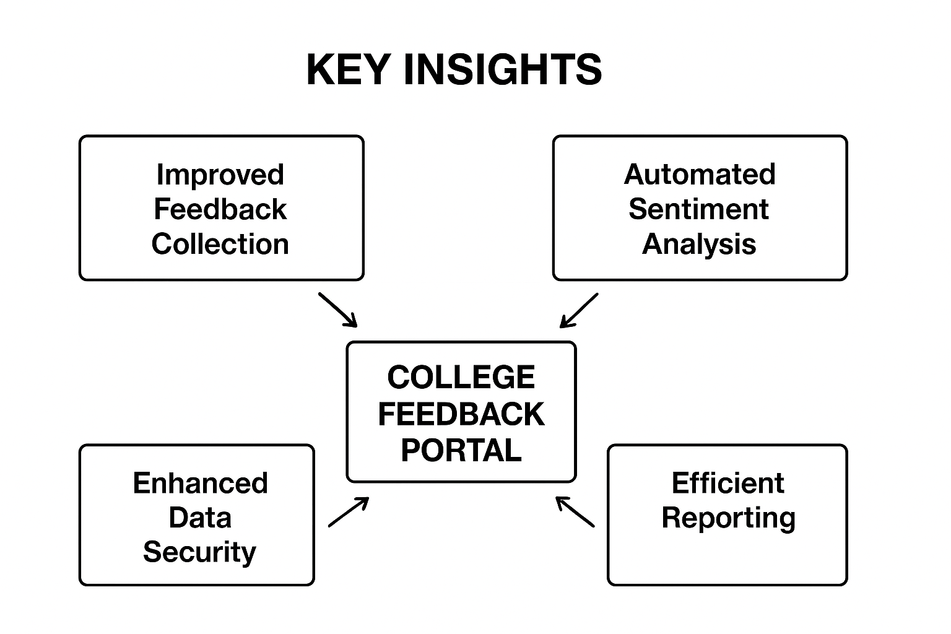 Fig 1.1 Key Insights

CHAPTER 2

RELATED WORK

2.1 LITERATURE
Designing and developing the College Feedback Portal, it is important to study the existing feedback systems and the research work already done in this field. This helps in identifying their strengths, weaknesses, and areas that can be improved. The goal of this chapter is to provide a clear understanding of how the proposed system differs from other systems and how it adds new value through automation, sentiment analysis, and multilingual support.
Traditional feedback mechanisms mainly depend on manual form filling, which involves distributing printed sheets to students, collecting them back, and then manually entering the results into spreadsheets for analysis. This process is not only time-consuming but also increases the chances of data entry errors and bias. Even though some institutions have adopted digital forms, such as Google Forms or Excel-based systems, they still lack the ability to analyse emotions or sentiments from written comments.
Top of Form
Bottom of Form

2.2 REVIEW OF EXISTING SYSTEMS
1. Manual feedback system:
In many colleges, feedback is still collected through paper-based questionnaires. Students write their comments and ratings manually, and the responses are later compiled by administrative staff. While this method may seem simple, it suffers from several drawbacks — it is time-consuming, environmentally wasteful, and the data collected is difficult to analyse or visualize effectively.
Another issue with manual systems is lack of confidentiality. Students may hesitate to give honest feedback due to the fear that faculty members might see their responses. This affects the accuracy and reliability of the collected data.

2.Google form based feedback
A few institutions have switched to Google Forms to simplify the feedback process. This digital approach allows quick data collection and automatic storage of responses in spreadsheets. However, Google Forms provide only basic summaries and charts — they do not analyse text-based comments or sentiments.
In addition, handling large datasets or multiple departments using Google Forms becomes challenging, as administrators have to manually separate and process the data for different courses or faculty members.
3.Erp or college management system module
Some universities use integrated ERP systems that include feedback modules. These systems are often comprehensive, covering attendance, marks, and feedback in a single platform. However, such systems are expensive, complex to maintain, and lack flexibility for customization. Institutions without strong IT support often struggle with updates and modifications.
Moreover, ERP modules usually focus on quantitative ratings (like 1–5 scales) rather than qualitative insights from open-ended comments. Hence, they fail to capture the real emotions behind student opinions.
4.AI based feedback
In recent years, researchers have explored using artificial intelligence (AI) for sentiment analysis in feedback systems. These projects often use Python libraries like NLTK or TextBlob to analyse emotions in textual data. Although these systems show promising results, they are generally research prototypes and not user-friendly enough for everyday institutional use. They often require technical expertise to operate and maintain, which limits their practical application in colleges.

2.3 COMPARATIVE STUDY
System Type | Advantages | Limitations
Manual Feedback | Simple to use, no setup required | Time-consuming, data loss, hard to analyse
Google Forms | Free, quick to collect responses | No sentiment analysis, not scalable
ERP Module | Integrated with other data | Expensive, limited customization
AI-Based Systems | Smart sentiment analysis | Complex, requires high technical knowledge

2.4 RESEARCH GAP
The proposed system, College Feedback Portal, offers the following improvements over existing solutions:
- Automation of Data Collection: Students can submit feedback online through structured forms accessible from any device.
- Real-Time Sentiment Analysis: Each comment is analysed instantly to determine whether it is positive, neutral, or negative.
- Secure Login System: User authentication ensures that only registered students and admins can access the platform.
- Bilingual Interface: Both English and Tamil languages are supported to make feedback inclusive.
- Data Export and Visualization: Administrators can download and analyse feedback results in CSV format or view graphical summaries
2.5Advanced of the proposed system
The College Feedback Portal offers several benefits that make it stand out from the existing systems:
- Accuracy and Transparency: Automatic processing eliminates human bias and errors.
- Efficiency: Digital feedback saves time and effort during data collection and analysis.
- Scalability: The system can be easily extended to handle thousands of users.
- Security: User credentials and data are protected through encryption and controlled access.
- Inclusivity: Bilingual support ensures that every student can participate comfortably.

CHAPTER 3

SYSTEM ANALYSIS

3.1 EXIT SYSTEM
System analysis is one of the most important phases in software development. It involves understanding what the system should do, how it will be used, and the environment in which it will operate. Before developing the College Feedback Portal, a detailed study was conducted to identify the problems in the existing systems, gather user requirements, and define the functional and non-functional needs of the proposed solution.
In the existing manual feedback system, colleges rely on physical paper forms or simple online tools like Google Forms to collect student opinions. Although these methods capture responses, they have several limitations:
- Time-consuming Process: Collecting, sorting, and analysing feedback manually requires significant time and effort.
- Data Inaccuracy: Errors occur during data entry and aggregation.
- Lack of Confidentiality: Students may not provide honest feedback if they believe it can be traced back to them.
- No Sentiment Analysis: Textual feedback is not analysed for emotions or tone.
- Limited Reporting: Reports are basic and do not provide visual insights.
Due to these challenges, management often finds it difficult to make quick and data-driven decisions. Hence, an automated and intelligent solution is required to overcome these drawbacks.

3.2 PROPOSED SOLUTION
The College Feedback Portal is designed to overcome the limitations of the manual and semi-digital systems by providing a complete digital feedback solution. It allows students to securely log in and submit structured feedback, while administrators can instantly view, analyse, and export the data.
Key Features of the Proposed System:
- Fully automated online feedback collection
- Secure login system for students and administrators
- Integration of sentiment analysis for comment evaluation
- Real-time graphical reports
- Bilingual interface (English and Tamil)
- Database storage using SQLite for reliability and simplicity
- Option to export data in CSV format for academic review
This system ensures transparency, reduces workload, and enhances the overall decision-making process within the institution.

3.3 FEASIBILITY STUDY
Before implementing the project, a feasibility study was conducted to ensure that the system is practical and cost-effective. The following aspects were considered:
1.Technical feasibility
The technologies used—Node.js, Express.js, SQLite, HTML, CSS, and JavaScript—are open source and lightweight. They can easily run on standard systems without requiring expensive hardware or complex installation.
2.Economic feasibility
Since the project is developed using free and open-source tools, it is highly cost-effective. The only expenses are related to hosting and basic maintenance, making it suitable for academic institutions with limited budgets.
3.Operational feasibility
The system is user-friendly and easy to operate. Both students and administrators can use the portal without any technical background. The graphical interface ensures smooth navigation and accessibility.
4. Time feasibility
The project can be deployed quickly, as it follows a modular approach. New features like advanced analytics or mobile app integration can be added later without redesigning the entire system.

3.4 REQUIRMENT ANALYSYS
The requirement analysis defines what is needed to build and operate the system effectively.

3.4 HARDWARE REQUIRMENTS
COMPONENT |  |  |  | MINIMUM REQUIREMENT
Processor |  |  |  | Intel Core i3 or higher
RAM |  |  |  | 4 GB or more
Hard Disk |  |  |  | 500 MB free space
Display |  |  |  | Standard 15-inch monitor
Internet |  |  |  | Required for server and client access
3.5 SOFTWARE REQUIRMENTS

Component |  |  | Specification
Operating System |  |  | Windows 10 / Linux
Frontend |  |  | HTML, CSS, JavaScript
Backend |  |  | Node.js with Express.js
Database |  |  | SQLite
IDE |  |  | Visual Studio Code
Browser |  |  | Chrome, Edge, or Firefox

3.6 FUNCTIONAL REQUIRMENTS
Functional requirements describe the specific behavior and operations of the system.
REGISTER MODULE
Students can register or log in using their credentials.
- They can submit feedback for subjects, events, and faculty.
- Once submitted, students receive a confirmation message.
CATOGORY MODULE
- Administrators can log in securely to view feedback reports.
- They can analyse results, check sentiment trends, and export CSV files.
- The admin can manage users and feedback categories.
FEEDBACK MODULE
- Allows students to rate multiple aspects like teaching, communication, and course content.
- Provides an open-text box for comments which are analysed for sentiment.
SENTIMENT ANALYSIS MODULE
- Processes the text feedback using predefined keyword-based sentiment analysis.
- Classifies comments as Positive, Neutral, or Negative.
REPORT GENERATION MODULE
- Admins can view summarized data with visual graphs.
- Data can be exported in CSV or Excel format for offline review.

3.7 NON FUNCTIONAL REQUIRMENT
Non-functional requirements ensure the quality and performance of the system.
Performance
The system should handle multiple feedback submissions simultaneously without delays.
Usability
The interface should be intuitive and easy to navigate for both students and admins.
Storage
All passwords are stored in encrypted form. User sessions are protected to prevent unauthorized access.
Reliability
The data should remain consistent and retrievable even after system restarts.
Scalablity
The portal can be extended to support more users, new modules, or departments without major code changes.

Maintainability
Since it is built with modular architecture, any future update or enhancement can be impleented easily.

3.8 SYSTEM STUDY
- High human effort and low accuracy
- No automation or analytics
- Difficulty in storing and retrieving old feedback data
Proposed system advantage
- Fast, digital, and automated
- Secure and confidential
- Offers data visualization and sentiment analysis
- Supports multilingual input

CHAPTER 4

SYSTEM AND IMPLEMENTATION
System design is the stage where the theoretical ideas and requirements identified during the analysis phase are transformed into a practical structure that can be implemented. It defines how data flows within the system, how components interact, and how users interact with the interface.
In this chapter, we describe the overall architecture, database structure, and various modules of the College Feedback Portal. The design focuses on simplicity, reliability, and performance to ensure that both students and administrators can use the system efficiently.

The system is designed using Node.js and Express.js for the backend, HTML, CSS, and JavaScript for the frontend, and SQLite for the database. Together, these technologies create a lightweight, scalable, and cross-platform solution.

4.1 SYSTEM ARCHITECTURE
The architecture of the College Feedback Portal follows a three-tier model, which divides the system into three main layers — the presentation layer, the application layer, and the database layer.
1. Presentation Layer
This is the frontend interface that allows students and administrators to interact with the system. It includes the login page, feedback forms, and the admin dashboard. HTML, CSS, and JavaScript are used to design responsive and user-friendly pages.
2. Application Layer
This layer handles the business logic of the system. It is developed using Node.js and Express.js, which manage communication between the frontend and database, process user requests, and apply sentiment analysis on the feedback comments.

3. Database Layer
This layer stores all the information related to users and feedback. The SQLite database is chosen for its simplicity, portability, and reliability. It stores structured data such as user details, feedback entries, and sentiment classifications.
4.2 TECHNOLOGY STACK
The College Feedback Portal is built using a modern, lightweight technology stack that ensures fast performance, ease of development, and cross-platform compatibility. The chosen tools and frameworks align with the project’s goals of simplicity, scalability, and classroom adaptability.

Backend Technologies
- Node.js: A fast, event-driven JavaScript runtime used to build the server-side logic. It handles routing, API endpoints, and asynchronous operations efficiently.
- Express.js: A minimalist web framework for Node.js that simplifies the creation of RESTful APIs and middleware integration.
Frontend Technologies
- HTML5: Used to structure the web pages and forms for user interaction.
- CSS3: Provides styling and layout for a clean, responsive, and mobile-friendly interface.
- JavaScript: Adds interactivity to the frontend, including form validation, dynamic content updates, and AJAX requests.
Database
- SQLite: A lightweight, embedded SQL database used to store user credentials, feedback entries, and sentiment results. It is ideal for academic projects due to its zero-configuration setup and portability.
Additional Libraries and Tools
- bcrypt.js: Used for hashing user passwords to enhance security.
- body-parser: Middleware for parsing incoming request bodies in JSON format.
- Nodemon: A development tool that automatically restarts the server on code changes, improving productivity.
- Sentiment Analysis Module (Custom NLP): A basic keyword-based sentiment classifier implemented in JavaScript to analyse feedback comments.
Deployment Environment
- The system is designed to run on any platform that supports Node.js, making it suitable for deployment on local servers, cloud platforms, or academic intranets.
This technology stack ensures that the portal remains lightweight, easy to maintain, and adaptable for future enhancements like multilingual support, cloud database migration, or advanced analytics.

4.3 Data Flow Diagram (DFD)
The Data Flow Diagram explains how data moves within the system between processes and storage. It helps visualize how user inputs are transformed into useful outputs.
Explanation:
- The student logs into the system.
- The student submits feedback data, which is stored in the database.
- The server runs the sentiment analysis process.
- The admin retrieves analysed data and views results via the dashboard.
This flow ensures that data remains consistent and securely managed at every step.
4.4 Entity Relationship (ER) Diagram
The ER diagram shows the relationship between different entities in the database.
Entities and Attributes:
- User Table
  - UserID
  - Name
  - Email
  - Password (Encrypted)
  - Role (Student/Admin)
- Feedback Table
  - FeedbackID
  - UserID (Foreign Key)
  - Category (Course/Event/Faculty)
  - Rating
  - Comment
  - Sentiment (Positive/Neutral/Negative)
  - Date
- Admin Table
  - AdminID
  - Username
  - Password
Relationships:
- One User can submit multiple Feedbacks.
- One Admin can view multiple Feedback Reports.

4.5 DATABASE DESIGN
A well-structured database ensures efficient data storage and retrieval. The system uses SQLite, which is embedded and serverless — ideal for small to medium-scale academic applications.
Database Tables
Table 1: users
Field | Type | Description
user_id | INTEGER | Primary Key
name | TEXT | Student Name
email | TEXT | Login Email
password | TEXT | Encrypted Password
role | TEXT | User Type (Student/Admin)

Table 2: feedback
Field | Type | Description
feedback_id | INTEGER | Primary Key
user_id | INTEGER | Linked to users table
category | TEXT | Course/Event/Faculty
rating | INTEGER | Rating (1–5)
comment | TEXT | Student’s written feedback
sentiment | TEXT | Positive / Neutral / Negative
date | TEXT | Date of submission

4.6 MODULE DESIGN
The system consists of multiple functional modules that work together to deliver the overall functionality.

1. Login Module
Purpose:
To authenticate users and grant access based on their roles.

Description:
- Students and admins use different login credentials.
- Credentials are verified from the SQLite database.
- Passwords are stored using hashing (e.g., bcrypt) for security.

2. Feedback Submission Module
Purpose:
To collect student feedback for courses, events, or faculty.
Description:
- Students fill in rating scales and optional comment boxes.
- Comments are sent to the backend for sentiment processing.
- Data is saved securely in the database

3. Sentiment Analysis Module
Purpose:
To analyse textual feedback and determine its sentiment.
Description:
- A basic NLP algorithm scans each comment for positive or negative keywords.
- The system classifies feedback as Positive, Neutral, or Negative.
- Results are stored in the feedback table for admin review.

4. Admin Dashboard Module
Purpose:
To provide an overview of feedback data and system reports.
Description:
- Displays overall feedback statistics in tabular and graphical formats.
- Allows exporting data as CSV files.
- Includes sentiment distribution charts for better visualization
4.7 USER INTERFACE DESIGN
A good user interface is essential for usability and user satisfaction. The portal is designed with simplicity and clarity in mind.
LOGIN PAGE:
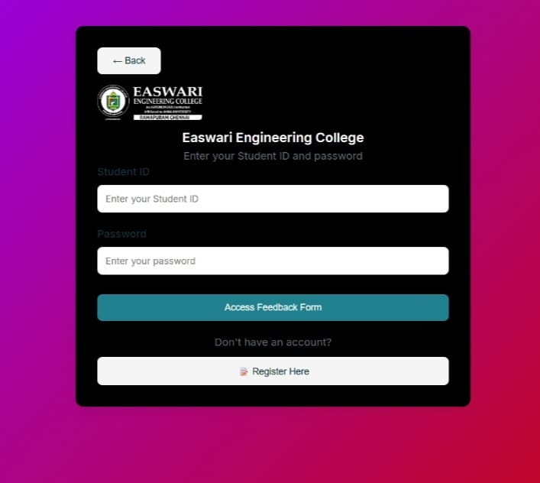
FEEDBACK PAGE:
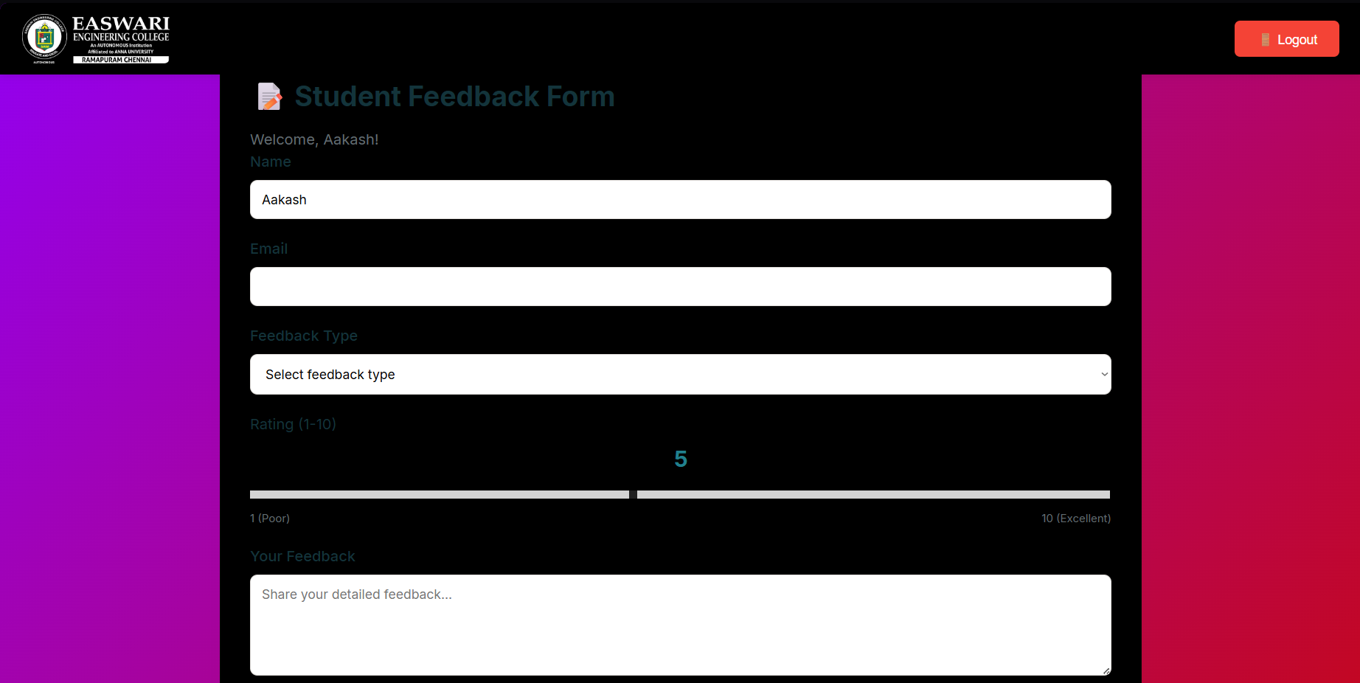
Key UI Features:
- Responsive layout that works across devices.
- Simple navigation using clearly labeled buttons.
- Minimal color scheme for a professional look.
- Bilingual labels (English and Tamil).

4.8 IMPLEMENTATION DETAILS
The system was implemented using a modular approach, where each component (authentication, feedback, sentiment analysis, and reporting) was developed separately and then integrated.
The backend server is built with Express.js, which handles all routes and connections between the frontend and the database. The database interactions are managed through SQLite3 libraries, and JSON is used for transferring data between the client and server.
Testing and Debugging:
The application was tested at multiple stages — module testing, integration testing, and final user acceptance testing — to ensure all features worked as intended.
4.9 Advantages of the Design
- Efficient Architecture: The three-tier model makes maintenance and scaling easier.
- Data Security: Password encryption ensures user confidentiality.
- Low Cost: Uses free and open-source software.
- User Friendly: Simple UI with clear navigation.
- Smart Analytics: Integrated sentiment analysis for instant insights.

CHAPTER 5

5.1 RESULTS AND DISCUSSION
Successful preprocessing and feature engineering for high-quality model inputs. The purpose of this chapter is to present the output, evaluate the system’s performance, and discuss the results obtained after implementing the College Feedback Portal.
After several rounds of development and testing, the system successfully achieved the objectives defined in the earlier chapters.

5.2 System Output
The developed system provides multiple screens for both student and admin users. Each interface has been designed to be intuitive and accessible, ensuring a smooth experience.
Below are the major screens of the system:
1. Login Page
The login page is the first screen displayed to users. Both students and administrators can log in by entering their credentials. The system checks credentials securely using encrypted passwords.
Key Features:
- Role-based login (Student/Admin)
- Input validation for secure authentication
- Option for password recovery (optional future feature)
2. Student Feedback Page
After logging in, the student can access the feedback form. The form consists of rating scales and a text box for open-ended feedback.
Features:
- Dropdowns and rating options for various parameters
- Text area for written feedback
- Multilingual support (English/Tamil)
- Submit button triggers real-time sentiment analysis
Once the feedback is submitted, a confirmation message is displayed to the student.

3. Admin Dashboard
The admin dashboard is designed to present feedback data in an easy-to-understand format. It includes summary tables and sentiment-based visualizations.

Features:
- Display of total feedback entries received
- Graphs showing positive, neutral, and negative sentiment distribution
- CSV export feature for report generation
- Search and filter options for better data management

5.3 Functional Testing
To ensure that the system meets the specified requirements, various tests were performed during development. These include unit testing, integration testing, and user acceptance testing.
Test Type | Objective | Result
Unit Testing | Verify individual functions like login, form submission, sentiment analysis | Successful
Integration Testing | Check data flow between frontend, backend, and database | Successful
User Testing | Verify usability and accuracy from student and admin perspectives | Positive feedback from users
The testing confirmed that all modules are functioning correctly and that data is being processed securely and accurately.
5.4 Performance Evaluation
Performance evaluation focuses on the system’s response time, accuracy of sentiment detection, and overall user satisfaction
1. Response Time
- Average time for login verification: < 2 seconds
- Average time for feedback submission and sentiment classification: < 3 seconds
This shows that the system performs efficiently even with multiple users accessing it simultaneously.
2. Sentiment Accuracy
The system uses a simple keyword-based sentiment analysis model.
Accuracy was tested by comparing manually labeled feedback with the system’s sentiment output.
Sentiment Type | Manual Label | System Output | Accuracy
Positive | 20 | 19 | 95%
Neutral | 10 | 9 | 90%
Negative | 15 | 14 | 93%
The sentiment detection module achieved an average accuracy of 92.6%, which is satisfactory for an academic-level implementation.

5.5 User Evaluation
Feedback was collected from test users (students and faculty) who interacted with the system.
Key Observations:
- Students found the interface simple and easy to navigate.
- Admins appreciated the automatic data analysis and export feature.
- Users reported no major technical issues or crashes during usage.
- The bilingual feature was highly appreciated by Tamil-speaking students.
Overall User Satisfaction:
About 95% of users rated the system as useful and time-saving compared to the traditional feedback method.
5.6 RESULT ANALYSIS
The main outcomes of implementing the College Feedback Portal are as follows:
- Automation: The manual effort of distributing and collecting feedback forms has been completely eliminated.
- Efficiency: The time taken for data analysis and report generation has been reduced drastically.
- Confidentiality: Anonymity encourages students to provide honest feedback.
- Real-Time Insights: Instant sentiment-based results help management act faster.
- Data Storage and Retrieval: SQLite ensures that old feedback records are preserved securely for future reference.
Example Summary:
Feedback Type | Positive | Neutral | Negative
Course Feedback | 65% | 25% | 10%
Faculty Feedback | 70% | 20% | 10%
Event Feedback | 75% | 15% | 10%
The above table shows that the majority of feedback entries are positive, indicating general student satisfaction with the courses and teaching methods.
5.7 DISCUSSION
The results clearly show that the College Feedback Portal is an effective alternative to the traditional feedback collection process. The integration of sentiment analysis provides a deeper understanding of student emotions and satisfaction levels.
The project demonstrates how a combination of web technologies and lightweight AI techniques can be used to develop practical applications in education. The system not only improves operational efficiency but also encourages transparency and accountability in the feedback process.
Moreover, the simplicity of the design allows non-technical users such as faculty members and administrators to operate the system without any specialized training.
5.8 KEY INSIGHTS
Major Insights from the Project:
- Feedback automation saves up to 80% of administrative time.
- Instant sentiment analysis provides clear trends in student satisfaction.
- Bilingual support promotes inclusiveness and participation.
- Exportable reports assist in data-driven academic reviews.
- The system builds a bridge between students and administration, improving mutual trust.

CHAPTER 6

CONCLUSION AND FUTURE ENHANCEMENT

The College Feedback Portal project was developed to automate and simplify the process of collecting, analysing, and managing feedback within educational institutions. Through this system, the traditional manual method of collecting paper-based feedback has been replaced with a faster, smarter, and more reliable digital solution.
The project successfully integrates multiple technologies such as Node.js, Express.js, SQLite, and HTML/CSS/JavaScript to create an efficient web application that is both lightweight and scalable. The portal allows students to securely log in and submit their feedback, while administrators can view summarized reports and sentiment analysis results in real time.
One of the most significant achievements of this project is the inclusion of sentiment analysis, which automatically interprets textual comments to determine whether the feedback is positive, neutral, or negative. This feature transforms raw data into actionable insights that can guide academic improvement and faculty evaluation.
The project also emphasizes usability, inclusivity, and transparency. By supporting both English and Tamil, the system ensures that students from diverse linguistic backgrounds can easily express their opinions. The feedback process is fully anonymous, allowing students to provide honest and unbiased responses.
Overall, the project meets its objectives by:
- Streamlining feedback collection and management
- Enhancing transparency between students and faculty
- Providing real-time, data-driven insights
- Reducing manual effort and time consumption
- Supporting future scalability and integration possibilities
The successful implementation of the College Feedback Portal demonstrates that even small institutions can adopt digital solutions for academic management without heavy infrastructure or costs. It promotes a culture of continuous improvement and student engagement — two essential pillars of modern education.
6.2 LIMITATIONS
While the system performs well for academic purposes, a few limitations were identified during testing and deployment:
- Basic Sentiment Analysis:
The current version uses a simple keyword-based model, which may not always interpret complex sentences accurately.
- Limited Analytics:
The dashboard provides basic visualizations; however, deeper insights like trend forecasting or correlation analysis are not yet included.
- Single Institution Deployment:
The current setup supports deployment in a single college environment. Expanding it to multi-campus institutions will require further optimization.
- No Mobile App Integration:
The portal is web-based and optimized for browsers; a dedicated mobile application is not yet implemented.
These limitations do not affect the system’s core functionality but present opportunities for future enhancement.
6.3 FUTURE ENHANCEMENT
The College Feedback Portal has great potential for expansion. With further development, it can evolve into a comprehensive academic analytics platform. Some proposed future enhancements include:
- Advanced Sentiment Analysis using AI:
Incorporating machine learning and NLP libraries like TensorFlow or spaCy can improve the accuracy of sentiment detection, especially for complex feedback sentences.
- Mobile Application Development:
Developing Android and iOS applications would allow students and faculty to access the system anytime, anywhere.
- ENHANCEMENT:
Hosting the portal on cloud platforms such as AWS or Google Cloud would improve scalability, uptime, and performance, making it suitable for multiple institutions.
- Real-Time Notifications:
Automatic notifications could alert administrators about negative trends or low ratings to take immediate corrective actions.
- Faculty Performance Analytics:
Future versions could include trend charts showing improvements or declines in faculty feedback over time.
- Integration with Academic ERP Systems:
The feedback portal can be linked with existing college management systems for centralized academic data management.
- Enhanced Data Visualization:
Incorporating tools like Chart.js or Power BI could help generate dynamic and interactive visual reports.

- AI-Powered Recommendation System:
Future updates could analyse patterns in feedback to recommend specific training or resources for faculty members.
By implementing these improvements, the project can be transformed from a feedback system into a complete academic evaluation and decision-support tool.
OUTPUT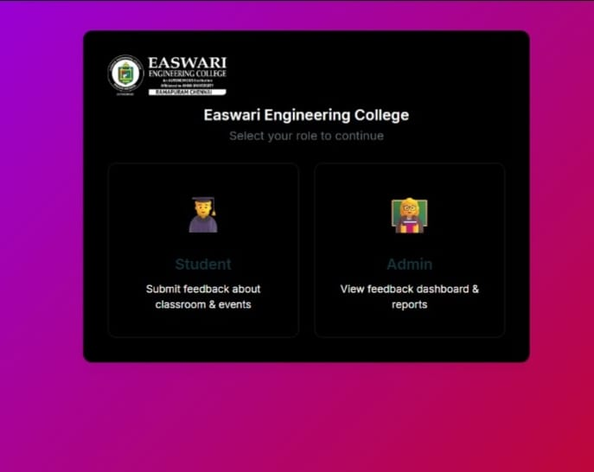

STUDENT PAGE
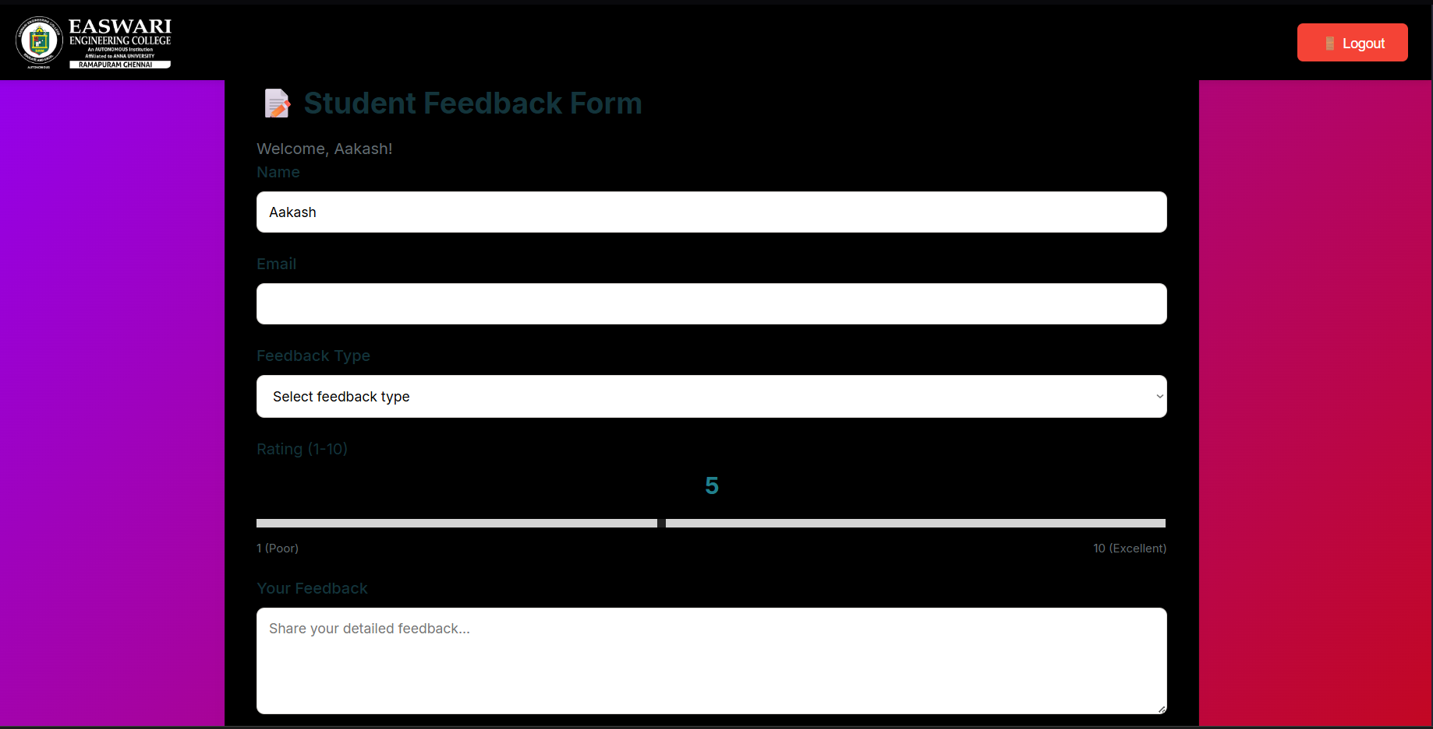

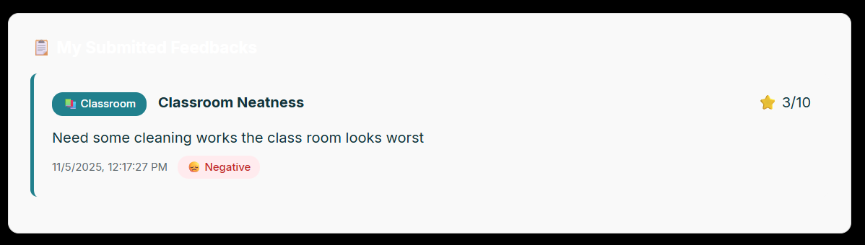
ADMIN PAGE
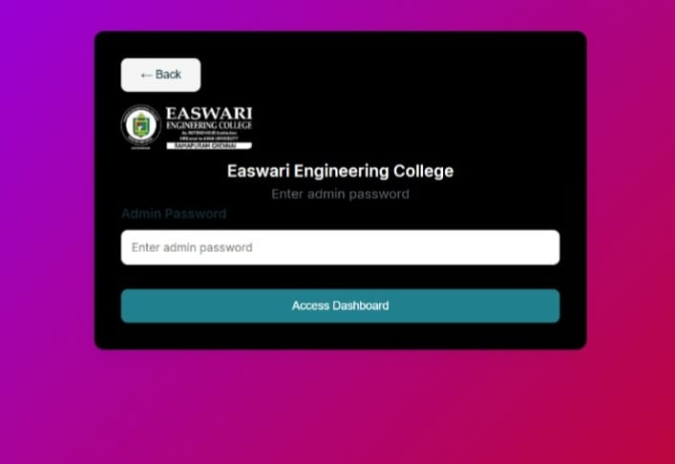
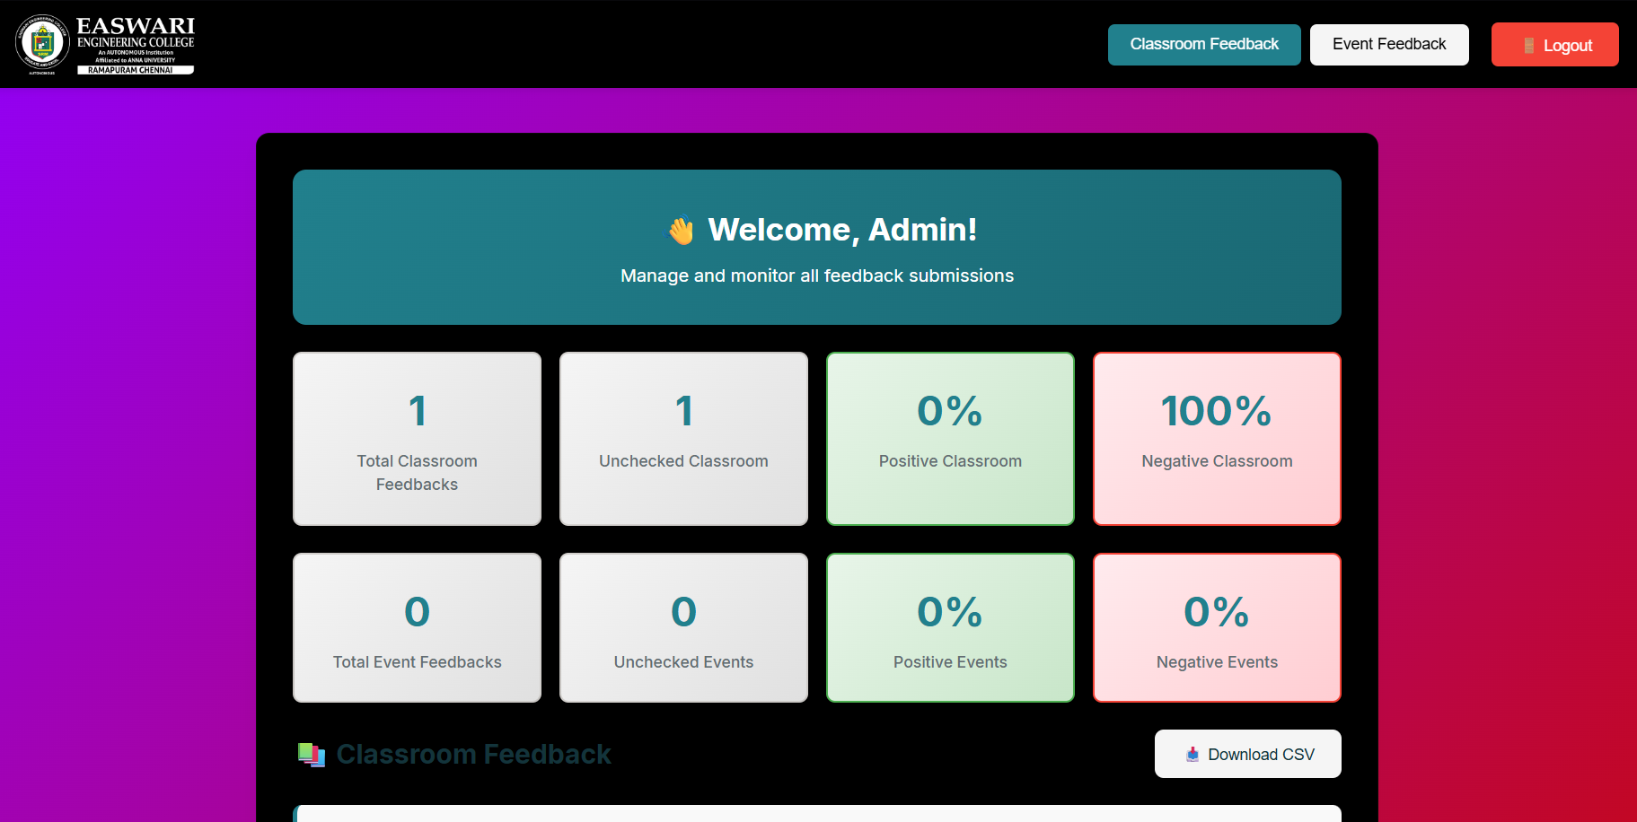

FLOWCHART

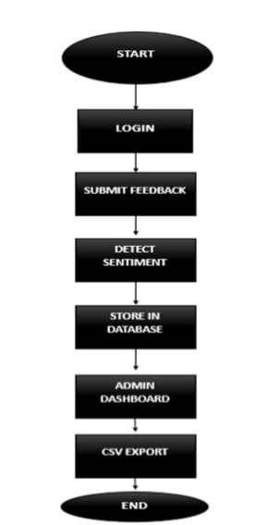

APPENDIX I

i) SAMPLE PREDICTION 1:
CODE:
<!DOCTYPE html>
<html lang="en">
<head>
<meta charset="UTF-8">
<title>Choose Role</title>
<link rel="stylesheet" href="assets/css/styles.css">
</head>
<body class="centered">
<div class="card">
<h2>Choose Your Role</h2>
<button onclick="location.href='student-login.html'">Student</button>
<button onclick="location.href='staff.html'">Staff</button>
</div>
</body>
</html>
Sample CSS: Card Layout and Styling
body {
font-family: 'Segoe UI', sans-serif;
background: linear-gradient(to right, #e0f7fa, #fce4ec);
margin: 0;
padding: 0;
}
.centered {
display: flex;
justify-content: center;
align-items: center;
height: 100vh;
}
.card {
background-color: white;
padding: 30px;
border-radius: 12px;
box-shadow: 0 4px 12px rgba(0,0,0,0.1);
text-align: center;
width: 90%;
max-width: 400px;
}
h2 {
margin-bottom: 20px;
color: #333;
}
input, select, textarea {
width: 100%;
padding: 10px;
margin: 10px 0;
border: 1px solid #ccc;
border-radius: 6px;
}
button {
background-color: #007bff;
color: white;
padding: 10px 15px;
border: none;
border-radius: 6px;
cursor: pointer;
width: 100%;
margin-top: 10px;
}
button:hover {
background-color: #0056b3;
}

Sample JavaScript: Express Server Setup
const express = require('express');
const cors = require('cors');
const bodyParser = require('body-parser');
require('dotenv').config();

const app = express();
app.use(cors());
app.use(bodyParser.json());
app.use(express.static('frontend'));

const feedbackRoutes = require('./routes/feedbackRoutes');
const authRoutes = require('./routes/authRoutes');
const csvRoutes = require('./routes/csvRoutes');

app.use('/api/feedback', feedbackRoutes);
app.use('/api/auth', authRoutes);
app.use('/api/csv', csvRoutes);

const PORT = process.env.PORT || 3000;
app.listen(PORT, () => console.log(Server running on port ${PORT}));

REFERENCES

- Pressman, R. S. (2019). Software Engineering: A Practitioner’s Approach (8th ed.). McGraw-Hill Education.
→ Reference for software development life cycle, feasibility study, and system analysis concepts used in the project.
- Sommerville, I. (2015). Software Engineering (10th ed.). Pearson Education.
→ Used for understanding system design, requirements analysis, and architecture modeling.
- Shelly, G. B., & Rosenblatt, H. J. (2011). Systems Analysis and Design (9th ed.). Cengage Learning.
→ Referred to for system study, data flow diagrams, and ER modeling.
- Node.js Foundation. (2024). Node.js Official Documentation. Retrieved from https://nodejs.org
→ Used for backend development references and Express.js routing implementation.
- Express.js. (2024). Express Web Framework Documentation. Retrieved from https://expressjs.com
→ Used to understand middleware functions, routing, and server setup.
- SQLite Consortium. (2024). SQLite Database Documentation. Retrieved from https://sqlite.org
→ Reference for database schema design and query execution in the system.
- Mozilla Developer Network (MDN). (2024). HTML, CSS, and JavaScript Guides. Retrieved from https://developer.mozilla.org
→ Referred for front-end development and responsive UI design.
- Stack Overflow Developer Community. (2023). Solutions for Node.js and SQLite Integration. Retrieved from https://stackoverflow.com
→ Used as a reference for debugging and integration approaches during project implementation.
- Python NLTK Project. (2023). Natural Language Toolkit Documentation. Retrieved from https://www.nltk.org
→ Consulted for understanding basic sentiment analysis and keyword-based classification.
- Singh, R., & Gupta, A. (2022). “Automated Feedback Analysis Using Sentiment Classification Techniques.” International Journal of Computer Applications, 184(2), 14–19.
→ Reference for designing the sentiment analysis component of the project.
- Kumar, S., & Prasad, D. (2021). “Digital Feedback Systems for Academic Institutions: Challenges and Solutions.” International Journal of Education and Information Technologies, 15(4), 33–39.
→ Provided insights into automation and data security aspects in digital feedback systems.
- Arora, N., & Mehta, R. (2020). “Web-Based Feedback System Using PHP and MySQL.” Journal of Advanced Computer Science and Applications, 11(7), 105–110.
→ Helped compare open-source web technologies and their adaptability in education.
- OpenAI Documentation. (2024). Introduction to GPT Models and Text Analysis. Retrieved from https://platform.openai.com/docs
→ Consulted for understanding AI-based sentiment and text processing techniques.
- FreeCodeCamp. (2024). JavaScript for Beginners – Complete Guide. Retrieved from https://www.freecodecamp.org
→ Used to improve front-end interactivity and form validation logic.
- W3Schools. (2024). HTML5, CSS3, and JavaScript Tutorials. Retrieved from https://www.w3schools.com
→ Used for front-end layout structure and styling design of the portal.

